**DevOps Lifecycle**

* DevOps is a collaborative practice that integrates development and operations into a single team, managing the entire application lifecycle.
* Combining “Dev” (development) and “Ops” (operations), it accelerates application and service delivery, with successful adoption by companies like Amazon and Netflix to enhance customer experiences.
* The DevOps lifecycle consists of phases designed for faster and more efficient software delivery. These include continuous development, integration, testing, monitoring, and feedback.
* Each phase uses tools and technologies, often open-source, tailored to business needs. This lifecycle simplifies management and ensures high-quality delivery.

**7 Cs of DevOps**

**1. Continuous Development:**

* Continuous Development involves writing code in small, incremental pieces rather than all at once. This approach enhances efficiency by allowing code to be tested, built, and deployed into production with every change.
* It raises the code's quality standards and simplifies the process of addressing flaws, vulnerabilities, and defects.
* By enabling developers to focus on producing high-quality code, Continuous Development streamlines the overall development process and aligns seamlessly with DevOps principles.

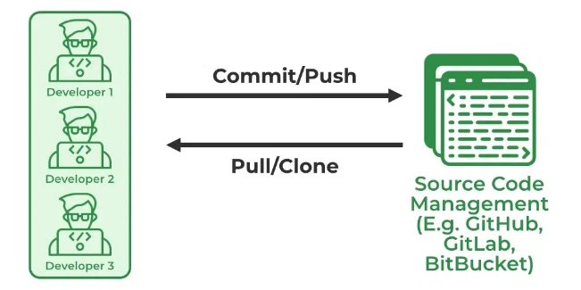

**2.Continuous Integration:**

1. **Source Code Management (SCM)**  
   Developers use tools like GitHub for SCM, where code is pushed from local machines to a shared repository. The repository allows authorized users to pull, clone, and modify the code collaboratively.
2. **Building the Code**  
   Tools like Maven are used to package the source code into deployable artifacts, such as WAR, JAR, or EAR files. Unit tests, such as JUnit cases, are executed during this stage.
3. **Code Quality Review**  
   SonarQube evaluates the quality of the source code, identifying issues and generating detailed reports in formats like HTML or PDF.
4. **Storing Build Artifacts**  
   Nexus stores the build artifacts created by Maven, ensuring a reliable repository for deployment-ready packages.

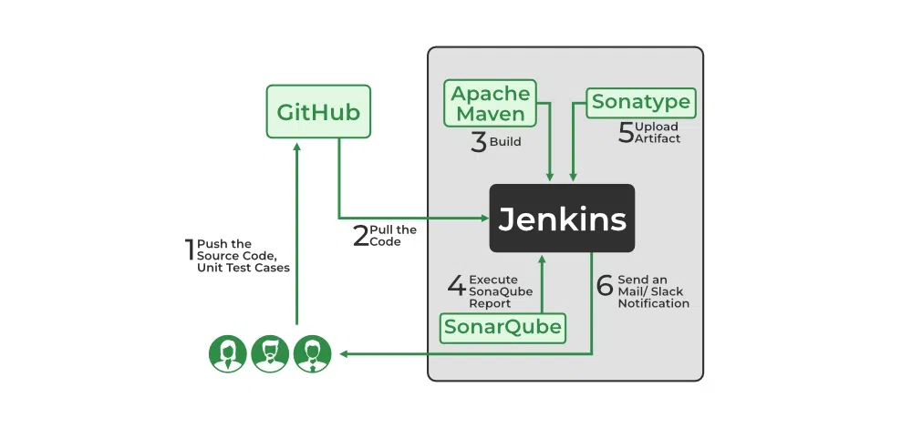

**3.Continuous Testing:**

* Continuous Testing integrates agile and DevOps methodologies to ensure thorough and efficient testing throughout the development lifecycle.
* It uses automation tools like **Testsigma**, **Selenium**, and **LambdaTest** to detect issues, eliminate code smells, and accelerate testing processes intelligently.
* Automating Continuous Testing through platforms like **Jenkins** enhances efficiency by seamlessly integrating testing into the CI/CD pipeline.
* This approach helps organizations identify problems early, maintain code quality, and ensure faster and more reliable software delivery.

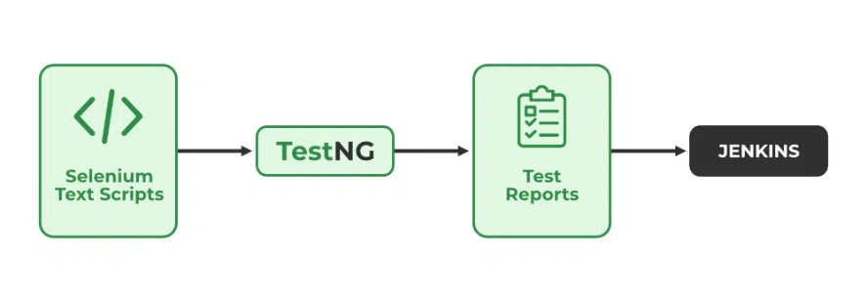

**4.Continuous Deployment:**

* Continuous Deployment is the automated process of deploying an application into the production environment once it successfully passes the testing and build stages.
* This approach eliminates manual interventions by automating the entire workflow—from obtaining the application's source code to deploying it.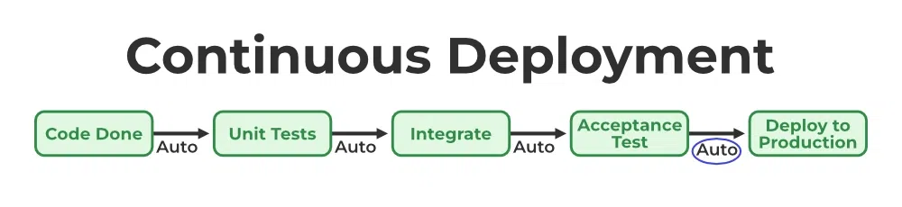
* [Continuous Delivery](https://www.geeksforgeeks.org/ci-cd-continuous-integration-and-continuous-delivery/) is the process of deploying an application into production servers manually when it has completed testing and the build stages.
* Here, we’ll automate the continuous integration processes, however, manual involvement is still required for deploying it to the production environment.

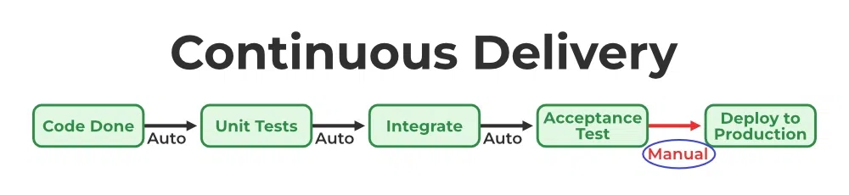

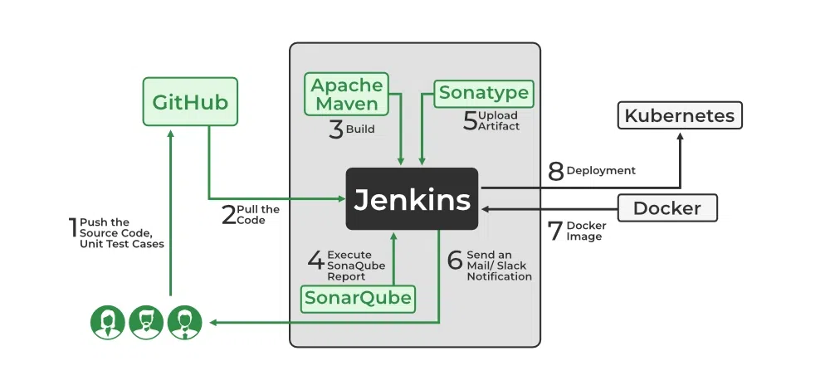

**5.Continuous Monitoring:**

* Continuous Monitoring is a vital phase of the DevOps lifecycle, ensuring the health and performance of applications and infrastructure.
* Tools like **Prometheus** collect performance metrics, such as CPU and memory usage, network traffic, application response times, and error rates.
* **Grafana** provides a visual representation of this data, enabling teams to monitor trends and take proactive measures to prevent issues.
* Continuous Monitoring helps in identifying potential problems early and ensures system reliability.

**6.Continuous Feedback:**

* Continuous Feedback involves gathering user input post-release to assess application performance and address glitches.
* Feedback is analyzed by the DevOps team, which collaborates with developers to rectify issues and optimize the code.
* This process helps reduce bugs, eliminate unnecessary deployment steps, and improve the user experience.
* Continuous Feedback enhances application quality and ensures alignment with user expectations.

**7.Continuous Operations:**

* Continuous Operations ensures high application uptime, reducing maintenance downtime and minimizing disruptions to the user experience.
* It supports better quality control, increased output, and lower operational costs.
* By sustaining uninterrupted operations, this phase enhances system reliability and optimizes resource efficiency.

**Phases of the DevOps Lifecycle**

1. **Plan**: Identify business needs and gather user feedback to create a project plan that optimizes impact and achieves desired results.
2. **Code**: Develop the code using tools like Git to ensure secure and high-quality coding practices.
3. **Build**: Use tools like Maven and Gradle to compile the code and submit it to a shared repository.
4. **Test**: Perform various tests (e.g., user acceptance, security, integration, performance) using tools like JUnit and Selenium to ensure software quality.
5. **Release**: Prepare the build for deployment by ensuring it meets all checks and is ready for production.
6. **Deploy**: Use Infrastructure-as-Code tools to set up the operational environment and publish the build.
7. **Operate**: Make the application available for users while managing server configuration and deployment with tools like Chef.
8. **Monitor**: Track application performance, user behavior, and system efficiency to identify and resolve issues, improving overall workflow.

**Advantages:**

1. **Speed**: Faster development and delivery of software updates.
2. **Efficiency**: Automated processes reduce manual tasks and errors.
3. **Collaboration**: Better communication and teamwork between development and operations.
4. **Quality**: Continuous testing and monitoring lead to higher-quality software.
5. **Scalability**: Easier to scale operations as demand grows.

**Disadvantages:**

1. **Complexity**: Integrating DevOps tools and practices can be complex.
2. **Cultural Shift**: Requires a significant change in company culture and mindset.
3. **Security Risks**: Faster deployment can sometimes lead to overlooked security issues.
4. **Initial Costs**: Upfront investment in tools and training can be high.
5. **Resource Intensive**: Requires skilled personnel and resources to implement and maintain.